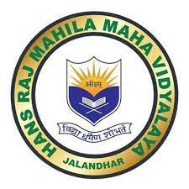
Hans Raj Mahila Maha Vidyalaya, Jalandhar
7.1.5
Green Campus Initiatives of the institution:

GEO-TAGGED PHOTOGRAPHS

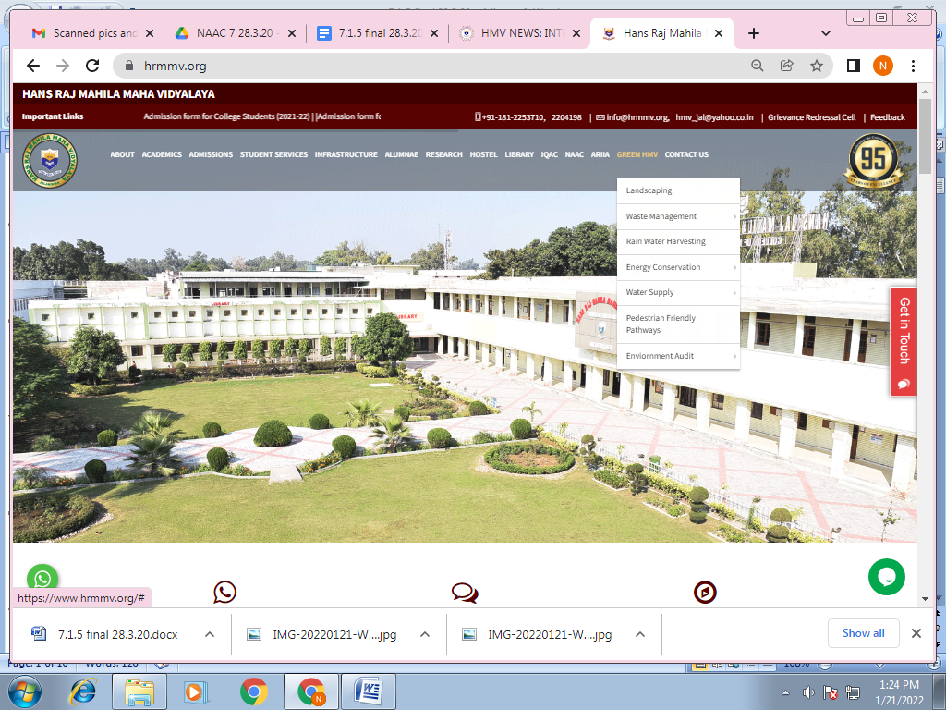
https://www.hrmmv.org/
GPS Location of the Institution
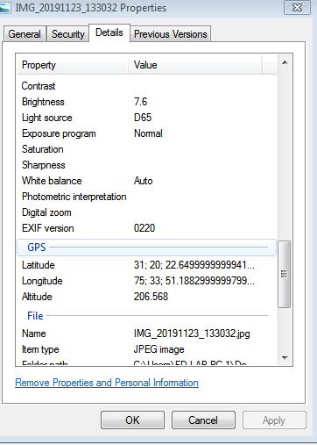
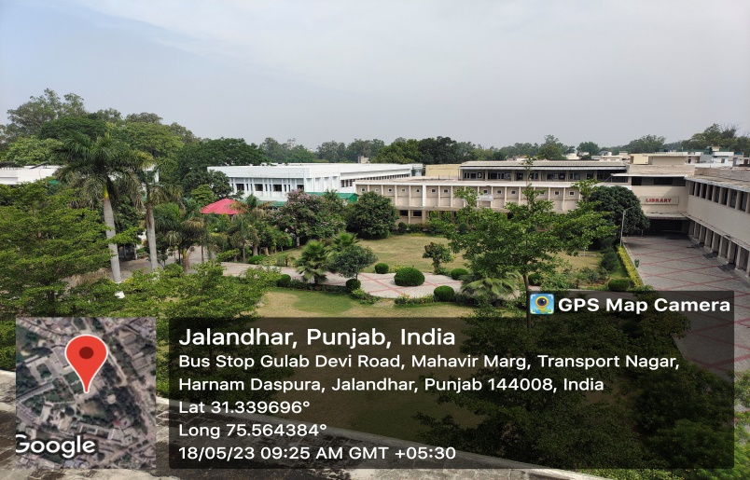

Initiatives | Photographs
1. Restricted entry of Automobiles  - Entry prohibited from main gate  - Entry pass for Cars from back gate  - Back gate car parking | 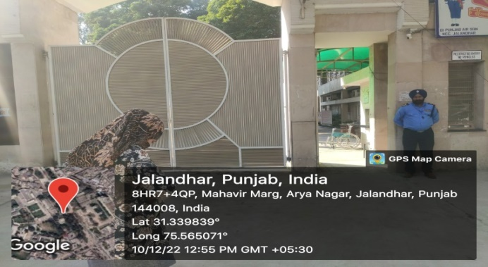  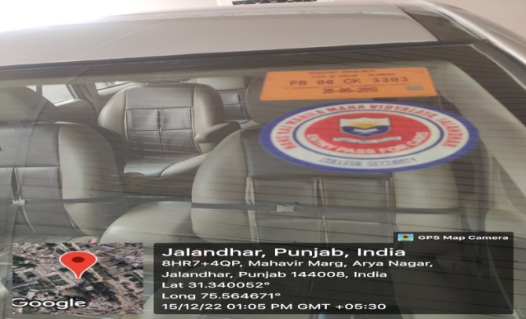  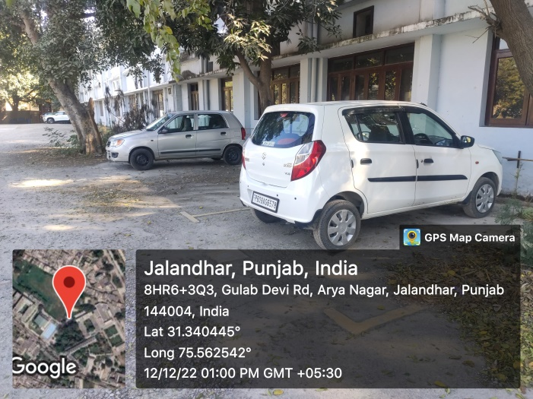
2.Battery Powered vehicles | 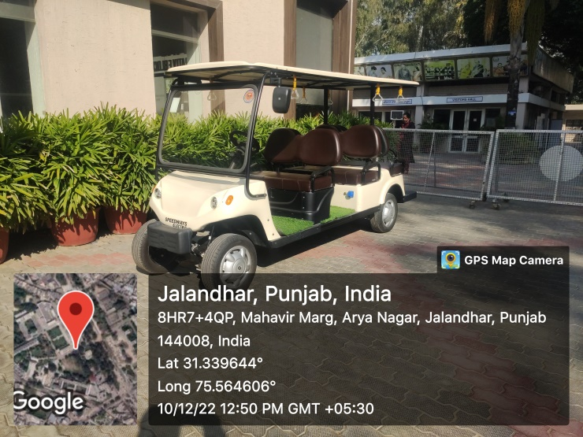
3.Pedestrian friendly pathways | 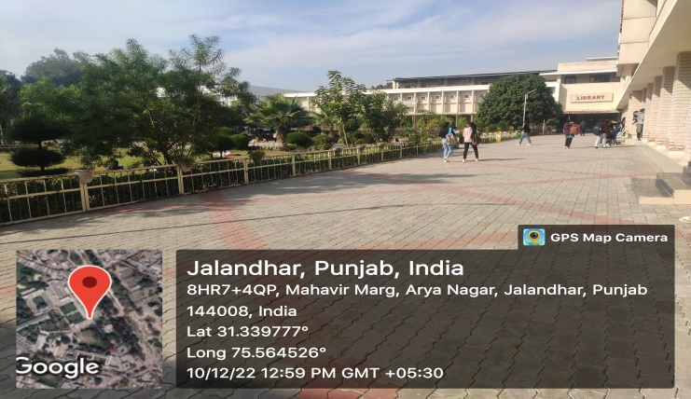  https://www.hrmmv.org/pedestrian.php
4.Ban on the use of plastic | 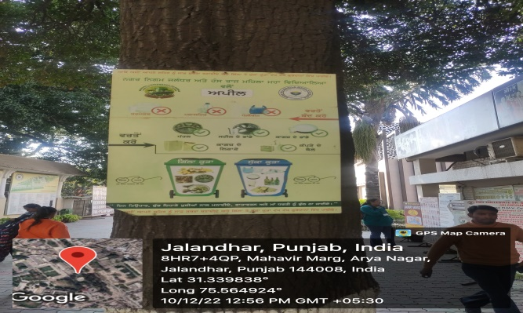  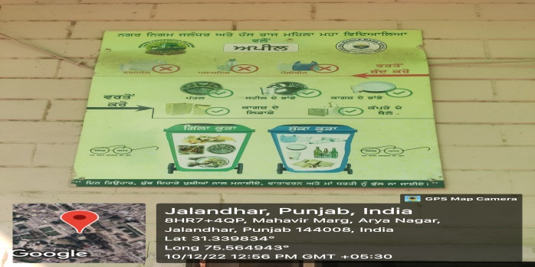
5.Landscaping with trees and plants | 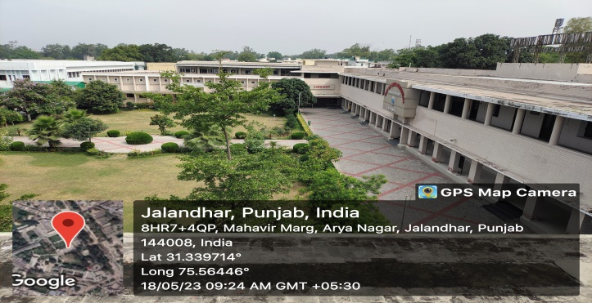  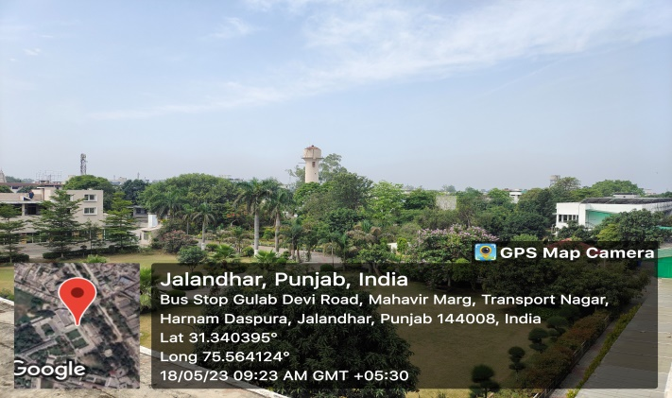  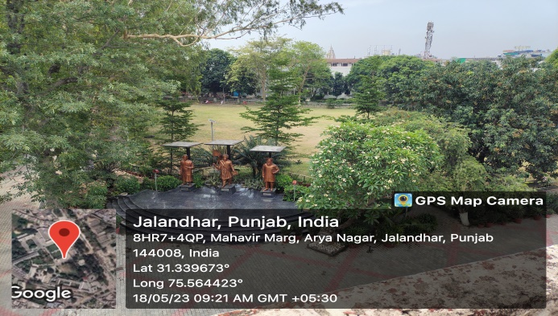  https://www.hrmmv.org/landscaping.php

